**Aim:** Implement Classification using MapReduce technique.

**Objective:**

To introduce several new algorithms for big data mining like classification, clustering

and finding frequent patterns.

**Outcome:**

1. Construct scalable algorithms for large Datasets using Map Reduce techniques.

2. Implement algorithms for classifying and finding associations in Big Data.

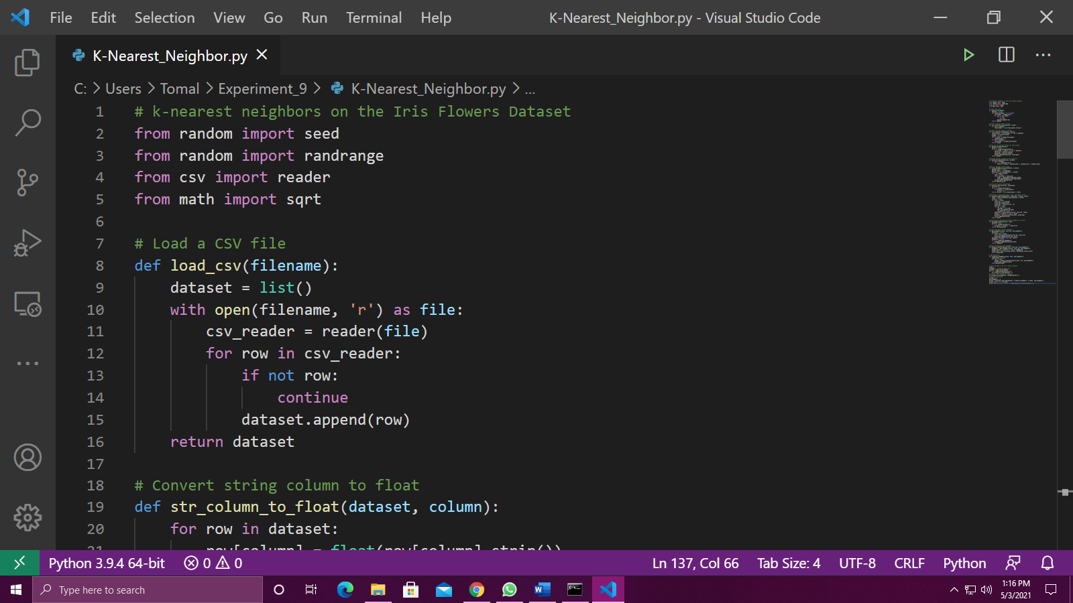

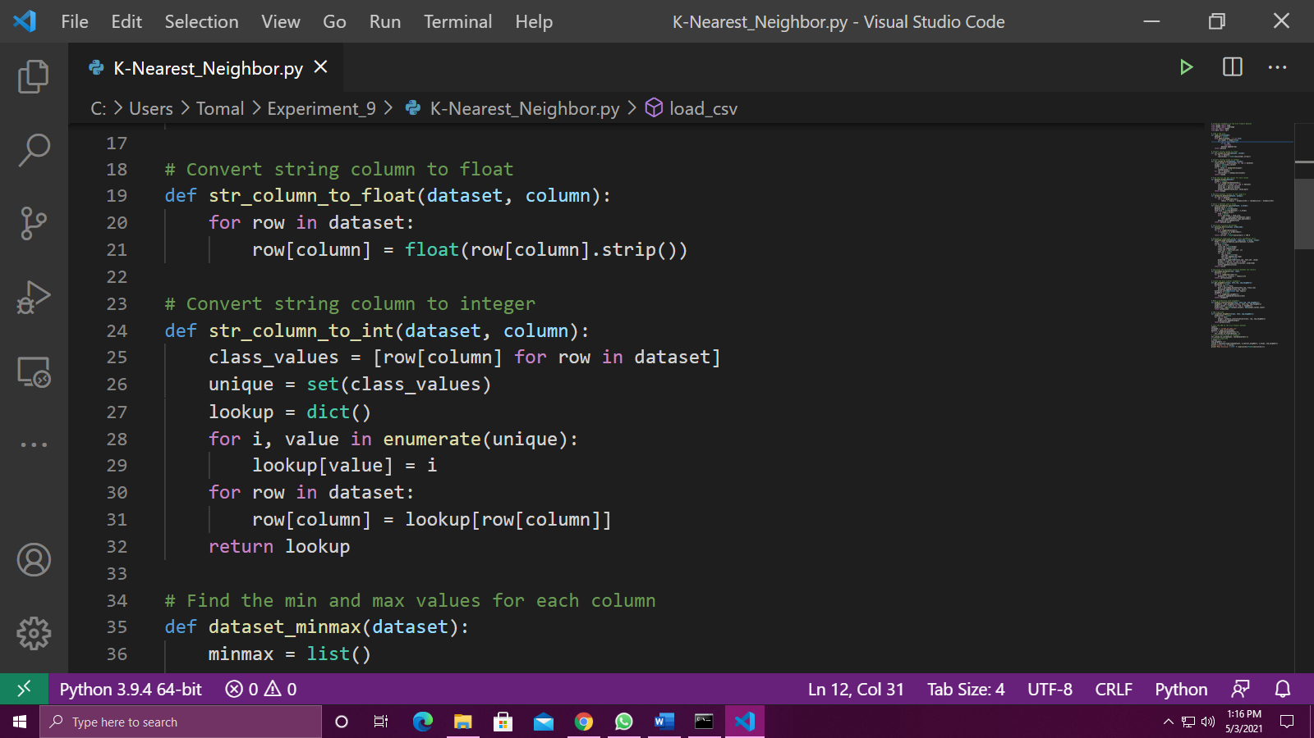

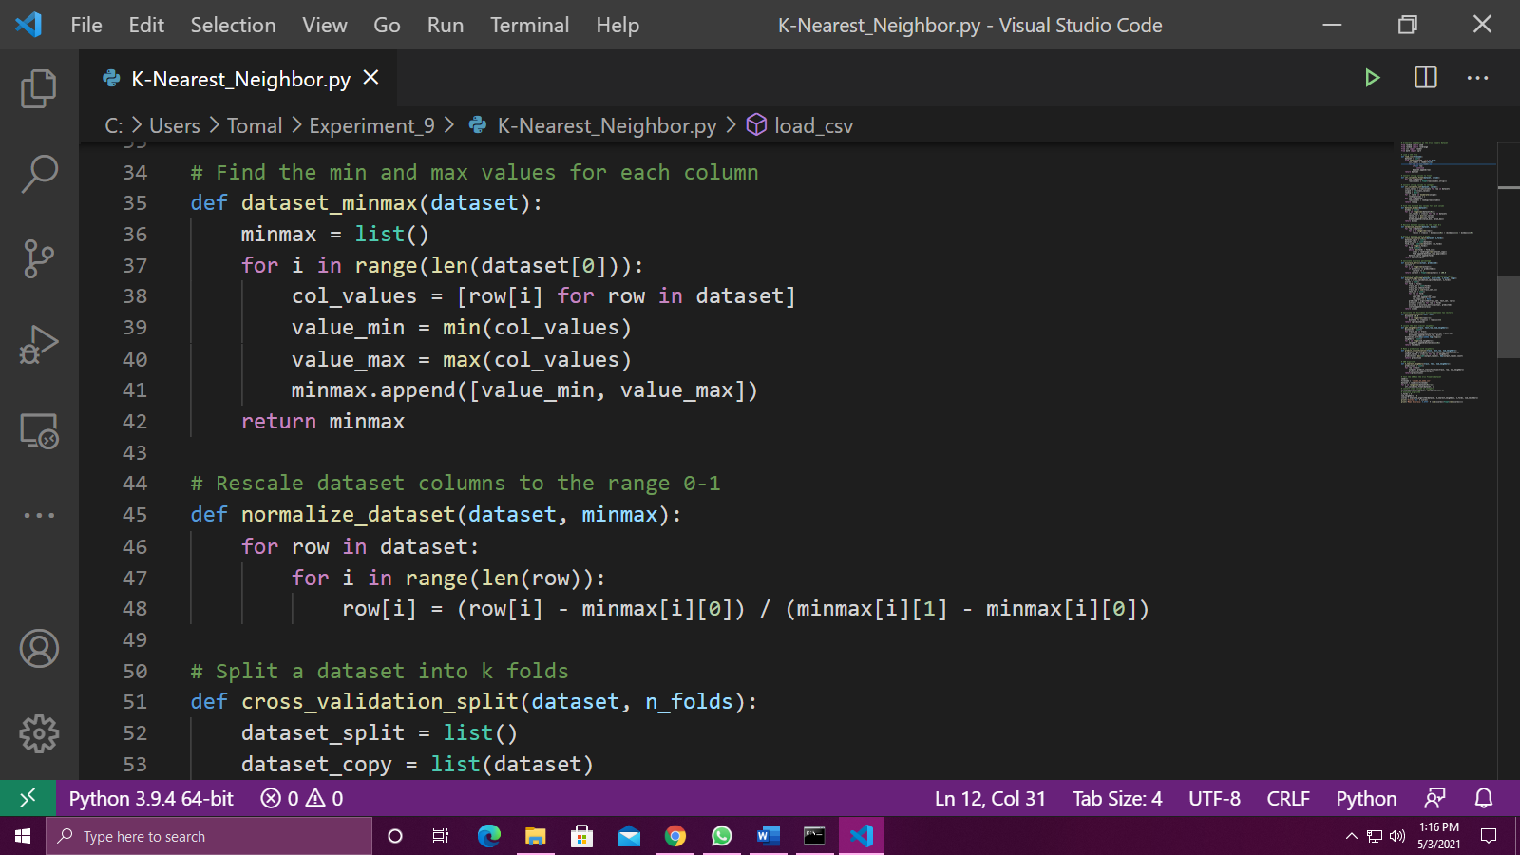

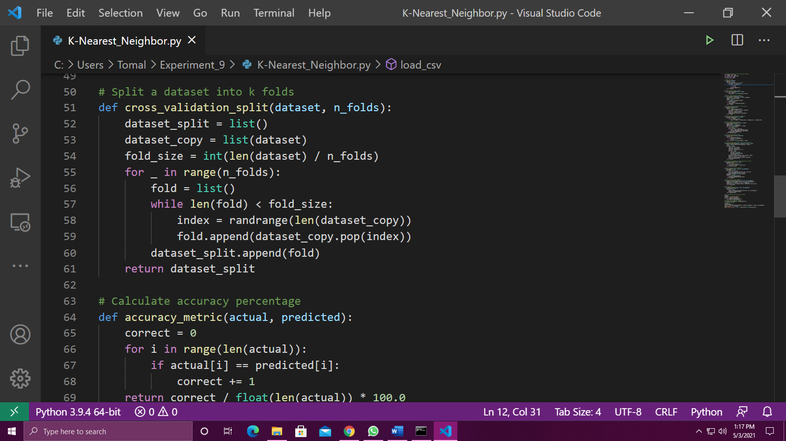

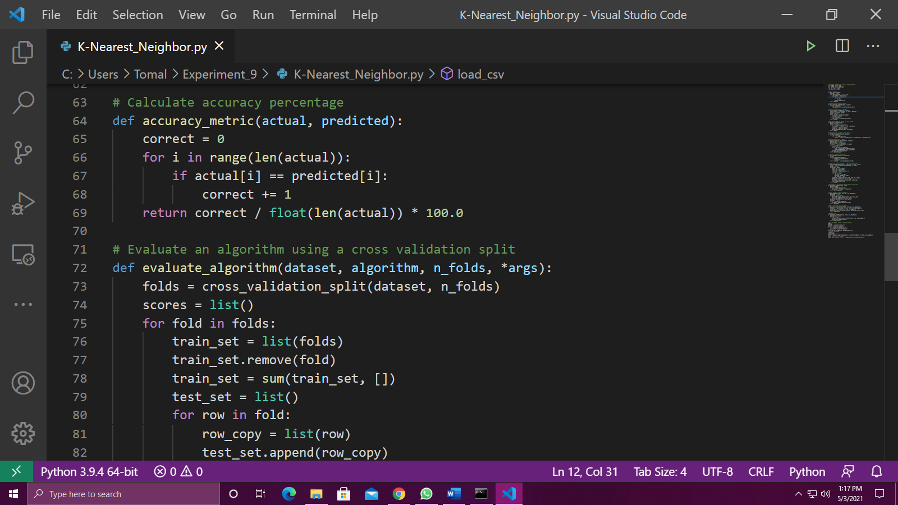

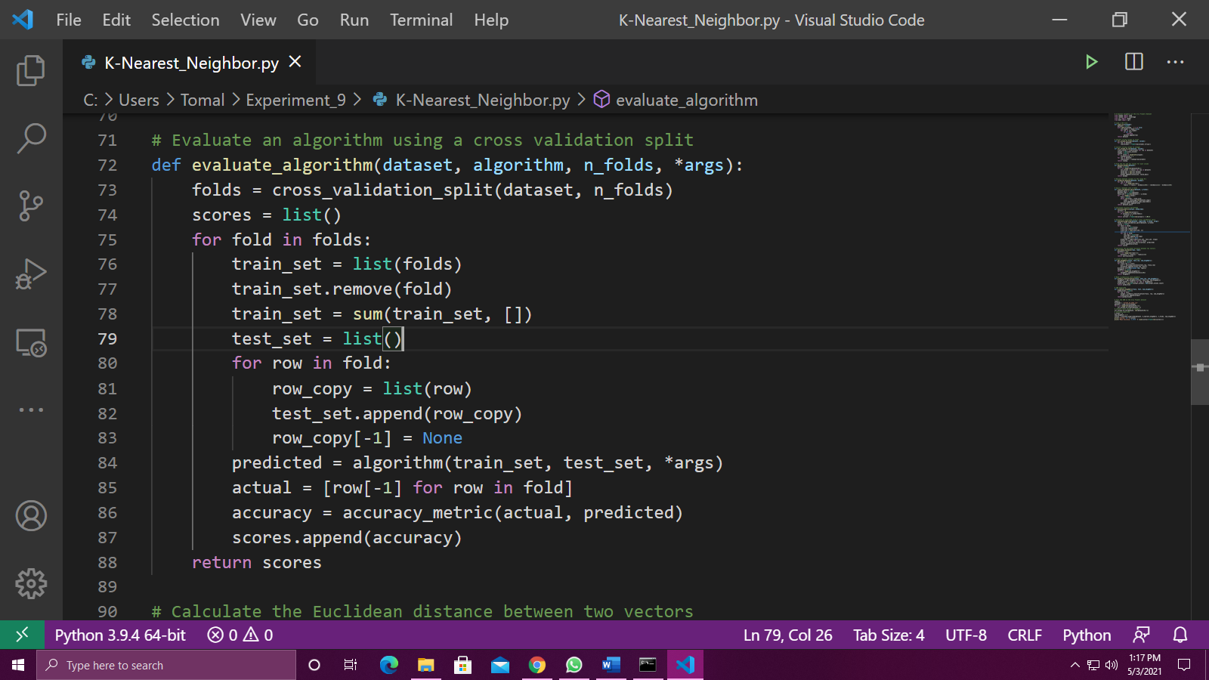

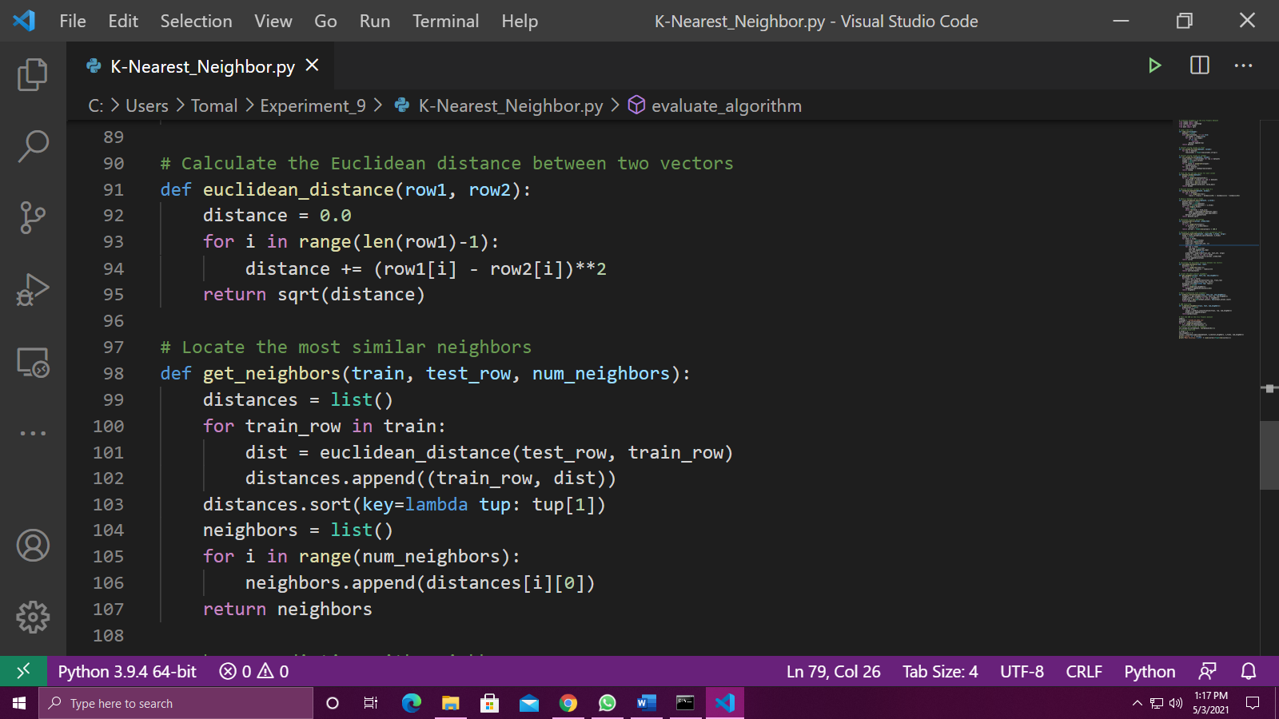

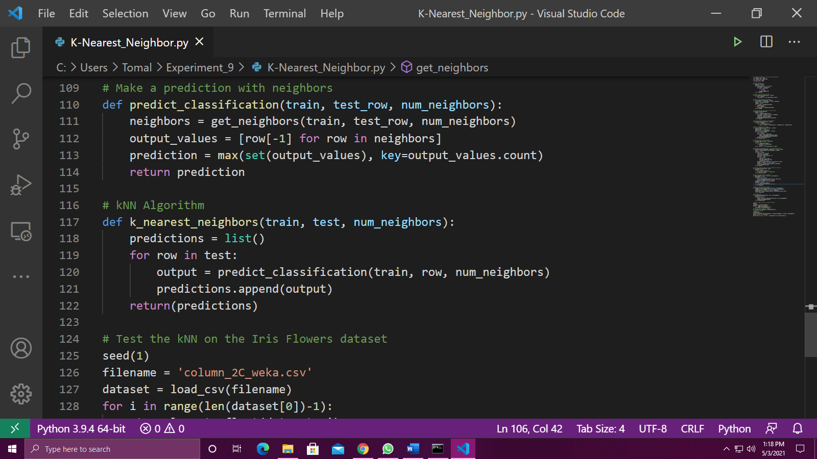

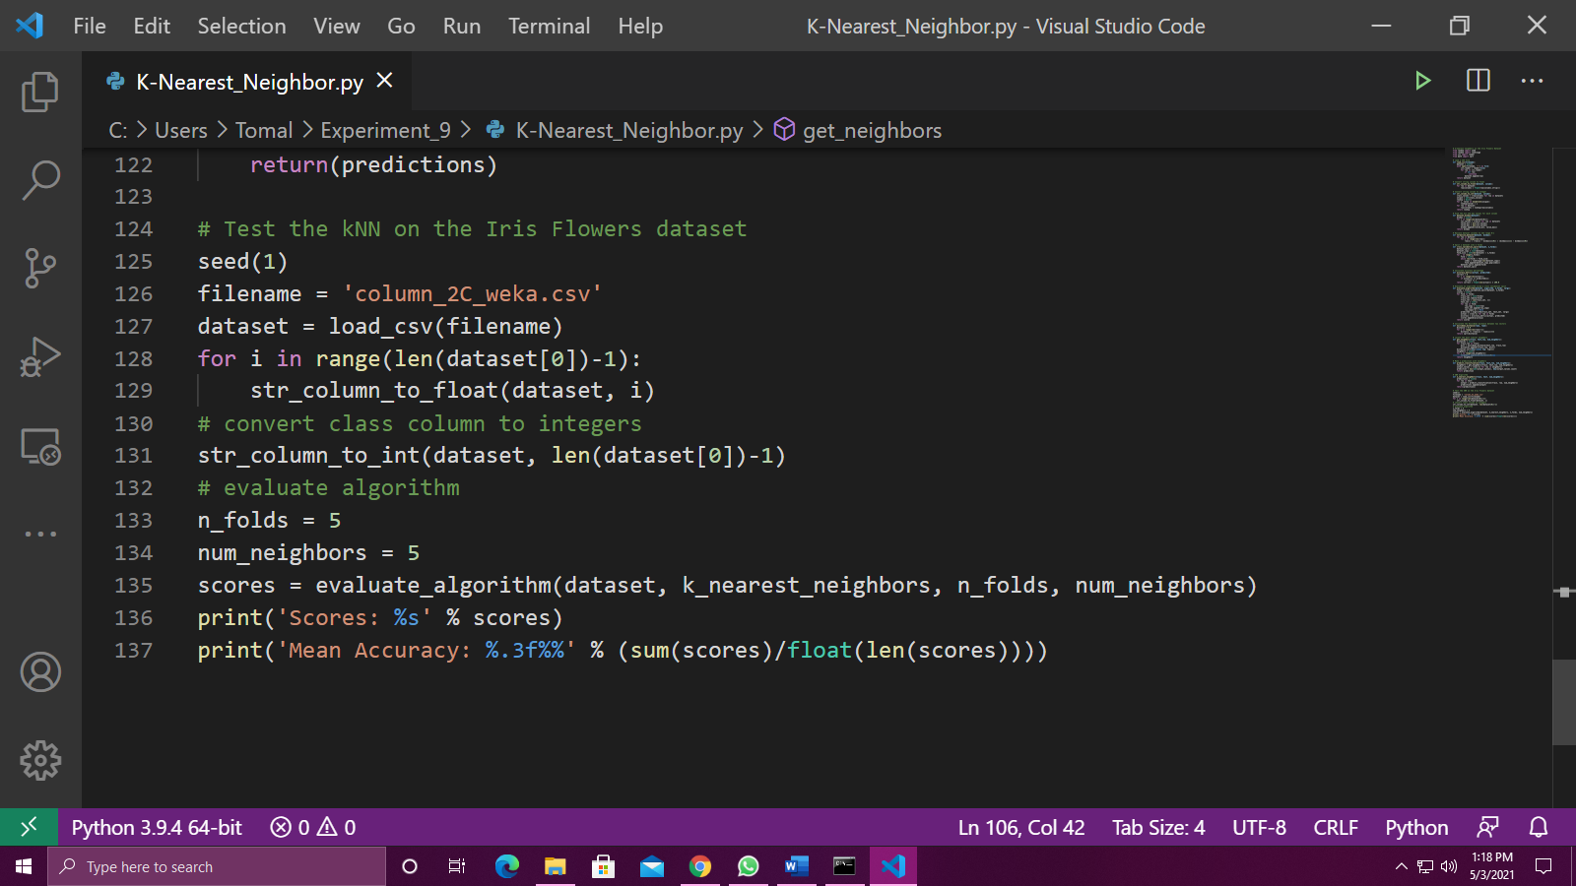

**Output:**

Running the example prints the mean classification accuracy scores on each cross-validation fold as well as the mean accuracy score.

We can see that the mean accuracy of about 85.484% is dramatically better than the baseline accuracy of 33%.



**Conclusion:**

From this experiment we have understood the concept of Classification and K Nearest Neighbors and also implemented the K Nearest Neighbors Algorithm.